Example 1: Solve the system of linear equations by elimination
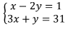

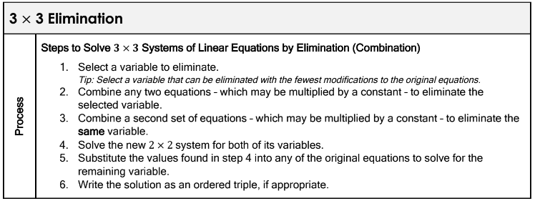
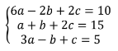
Example 2: Solve the system of linear equations by elimination

Example 3: Solve the system of linear equations by elimination
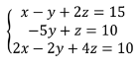

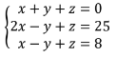
Example 4: Solve the system of linear equations by elimination

Example 5: Allen has $47 in 12 bills in his wallet, including ones, fives and tens. If he has two more one dollar bills than the combined number of fives and tens, how many of each denomination does Allen have in his wallet?
Formulate a system of linear equations to represent this situation. Then, use elimination to solve the system.

